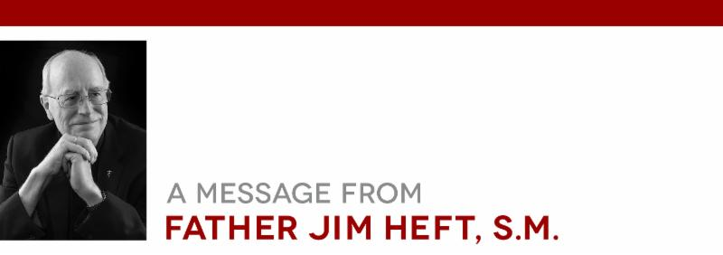

|  |  |
| --- | --- |
| |  | | --- | | **The Still-Unfolding Sexual Abuse Scandal** | |

|  |  |
| --- | --- |
| |  | | --- | | In 2002, I wrote a paper occasioned by the revelations of the sexual abuse in the Boston Archdiocese. My paper did not go beyond emphasizing multiple advisory roles within the Church for the laity. Since then, there have been continued reports of sexual abuse and cover ups by members of the hierarchy. Given the latest grand jury report on the horrific abuse in six dioceses in Pennsylvania and then the Cardinal McCarrick scandal, I realize now that something more needs to be done than asking the laity for advice. We need to deal with structures of authority, create some form of checks and balances, and reexamine the practice of only the ordained (priests and bishops) exercising all the decision-making power in the Church.  Nearly all of the bishops who expressed shame and anger did not address the elephant in the room: how authority is structured. I tell my students that one of the great assets of the Catholic Church is centralized authority, but also that it also tends to diminish a sense of responsibility for the life of the Church among the laity. Pope Francis announced at the beginning of his papacy that he wanted to effect an orderly decentralizing of authority in the Church without losing a center of authority. Francis also wants to get rid of clericalism, excessive deference to the ordained. I agree. But it is also my impression that few authority structures can realistically be expected to reform themselves, whether it be the executive branch of a government or the hierarchy of the Church. There needs to be, I think, something beyond the expectation that the hierarchy alone can reform itself. In actual fact, by reporting criminal sexual behavior of priests to the police, bishops have already recognized a legitimate authority outside themselves.  Yesterday, a good friend wrote to me about the value of prayer in the midst of this crisis: "If there is no underestimating the power of prayer, at least when it is heartfelt, the recently disclosed abuse of primarily male adolescents by priests suggests too many of us haven't really been praying." Along with heartfelt prayer, we must call for the more careful selection of bishops. Real change will not be effected by campaigns to purge homosexual priests and liberal bishops. Equally mistaken are those who claim that the culprit is Vatican II and the confusion about sexual morality some attribute to it or to the current pope. This is no time for either liberal or conservative Catholics to push their agendas.  Among the more thoughtful responses is that of an English bishop who has asked Pope Francis to convene an extraordinary meeting of the Synod of Bishops to address this crisis. Another response comes from a large group of young Catholics who have called on all the bishops in the United States to follow the example of the 31 bishops of Chile who all submitted their resignations to Pope Francis as "a public act of repentance and lamentation before God and God's People."  However, putting it all on the pope's desk, at least as a practice, is not wise for three reasons. First, not all popes have been good popes. In 1997, Cardinal Ratzinger, the future Benedict XVI, was asked whether he thought that the Holy Spirit played a direct role in the election of a pope. He said no because there were too many popes in history whom the Holy Spirit would not have chosen. He added that the only assurance that the Holy Spirit offers is that whoever is elected will not destroy the Church.  Second, expecting the pope to solve these crises reinforces centralized authority, leaving unaddressed the need for a mechanism for accountability within the Church that includes more than members of the hierarchy. And third, it reinforces a tradition that goes all the way back to the Council of Trent (1545-1563) that the laity, who form 99% of the Church, exercises no role in its governance.  In response to the scandal of Cardinal McCarrick's criminal behavior, Bishop Robert Barron recommends that the pope organize a group of mostly "faithful lay Catholics skilled in forensic investigation" with the power to determine who knew what when. I would slightly modify Bishop Barron's recommendation: I think that such a group needs to have some sort of permanent existence for the purpose of ensuring greater transparency and accountability from the hierarchy. It makes sense that each national bishops' conference should create such a body. These bodies, of course, should not replace the already existing forensic experts, namely police and district attorney's investigative units.  How to create such a body, and how to determine the authority it needs to do its job may require a change in Canon law, which for centuries has linked priesthood with all decision-making authority. Such a change, while radical, need not, and should not, lead to the abandonment of a center of authority in the Church. Our immediate priority should be to figure out how to do this.  We have faced major crises before, the schism between the Eastern and Western Churches, the Protestant Reformation, and the French revolution. The Church will be severely chastened by this sexual abuse crisis, but not destroyed. True as that is, the response to this latest crisis must address new structures of accountability that give real authority and agency to the laity.  Blessings, | |

|  |  |
| --- | --- |
| |  | | --- | | http://files.constantcontact.com/b33b7e12701/0e4900e8-800c-479e-ab13-121378ddd65a.jpg | |

|  |  |
| --- | --- |
| |  | | --- | | President, Institute for Advanced Catholic Studies  ﻿ | |